🌿🐚🐻🏡🕸️ BIOMIMICRY 🍃🐜🏗️🔬✨
Biomimicry means people learn from animals and nature to build new things.

Job 12:7–10 (NIV) ❓🤔🔍🧭🌿👀🗺️✨
But ask the animals, and they will teach you,
or the birds in the sky, and they will tell you;
or speak to the earth, and it will teach you,
or let the fish in the sea inform you.
Which of all these does not know
that the hand of the Lord has done this?
In his hand is the life of every creature
and the breath of all mankind.
🐶 🐱 🐻 🐰 🦊 🐼 🐨 🐯 🦁 🐸 🐵 🦉 🐧 🦔
🐟 🐬 🐳🦒 🦓 🦌 🐿️
🦋 🐞 🐜 🕷️ 🐢 🐍

🐚 Nautilus Shell → Dome Homes  Nature uses curved shapes to make strong shells.  People copy this to build strong dome homes.  Draw your own dome home: | 🐻 Bear Den → Earth Homes  Bears dig into hills for warm, safe dens.  People copy this by building homes into hills.  Draw your own earth home:
Next: Create a home out of clay!
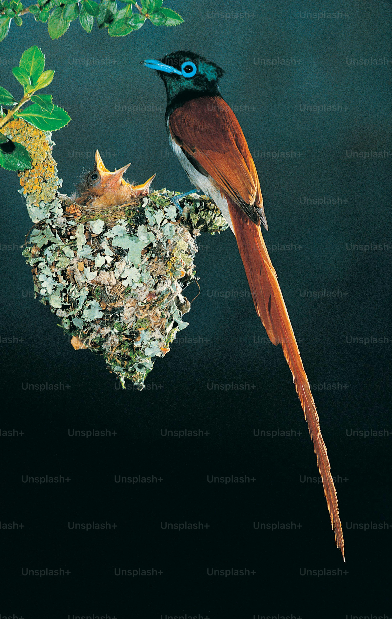
Psalm 148 (NIV) 🌌 ✨ ⭐️ 🌟 🌠
Praise the Lord.
Praise the Lord from the heavens;
praise him in the heights above.
Praise him, all his angels;
praise him, all his heavenly hosts.
Praise him, sun and moon;
praise him, all you shining stars.
Praise him, you highest heavens
and you waters above the skies.
Let them praise the name of the Lord,
for at his command they were created,
and he established them for ever and ever—
he issued a decree that will never pass away.
Praise the Lord from the earth,
you great sea creatures and all ocean depths,
lightning and hail, snow and clouds,
stormy winds that do his bidding,
you mountains and all hills,
fruit trees and all cedars,
wild animals and all cattle,
small creatures and flying birds,
kings of the earth and all nations,
you princes and all rulers on earth,
young men and women,
old men and children.
Let them praise the name of the Lord,
for his name alone is exalted;
his splendor is above the earth and the heavens.
And he has raised up for his people a horn,
the praise of all his faithful servants,
of Israel, the people close to his heart.
Praise the Lord

