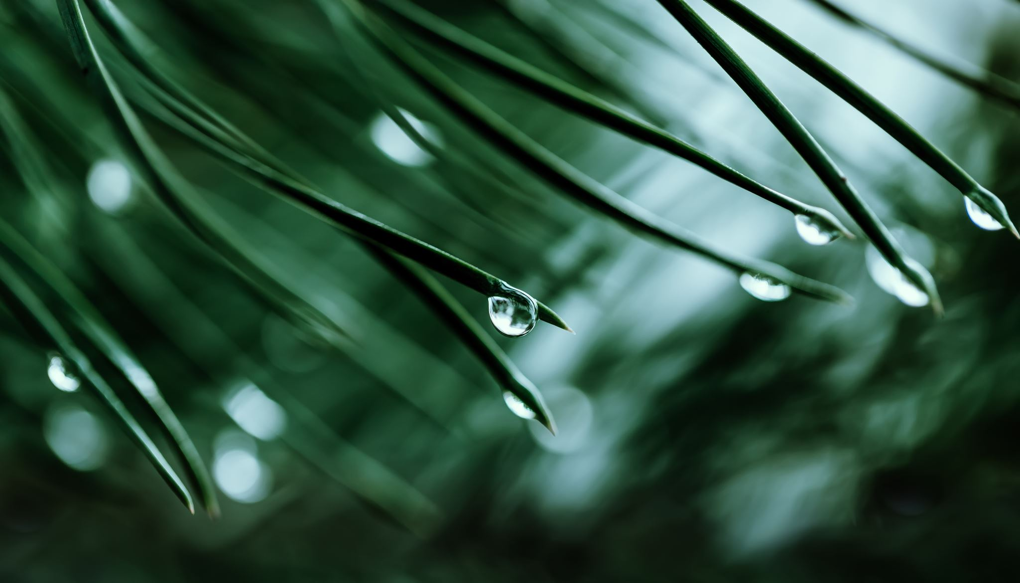
🌲 Biomimicry Worksheet: PIONEERS & PATRIOTS
Pine Branches & Roof Pitch 🏠

Challenge in Nature:
Pine trees grow strong branches at diagonal angles so that:
✔ Heavy snow slides off ❄️
✔ Wind load is distributed evenly 💨
✔ The trunk doesn’t break 🌳
✔ The branch supports weight without collapsing 💪
Human Problem:
Roofs can fail from heavy snow loads because:
❌ Snow builds up and stays
❌ Flat surfaces trap weight
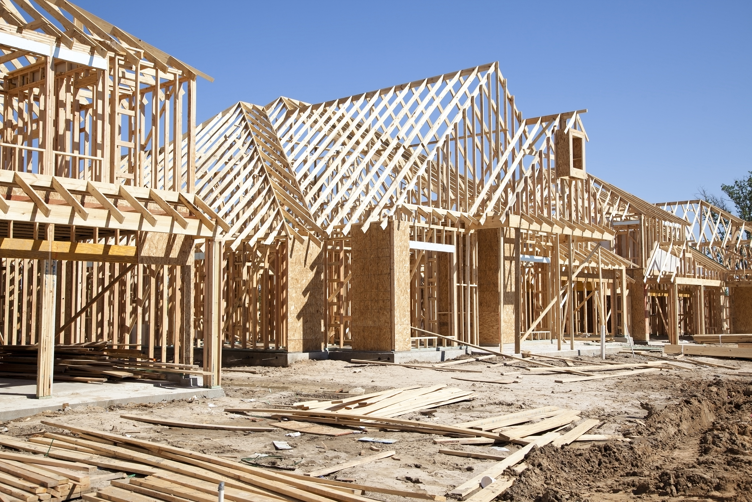
❌ Poor angles make water and snow sit too long

Biomimicry Solution:
Design a roof with a diagonal pitch (like pine branches)
so snow slides off naturally! 🏠🌲

Success Criteria:
✔ Roof sheds snow effectively
✔ Structure stays strong
✔ Uses materials efficiently
✔ Meets building codes

Constraints:
📌 Materials available
📌 Time to build
📌 Cost of production 💰
📌 Safety codes

📝 Fill in the Blanks!
1️⃣ The problem we are trying to solve is: ________________________________

2️⃣ The natural design we copied is: ________________________________

3️⃣ Our roof pitch angle will be: ________________________________

4️⃣ One material we will use is: ________________________________

5️⃣ One constraint we must think about is: ________________________________
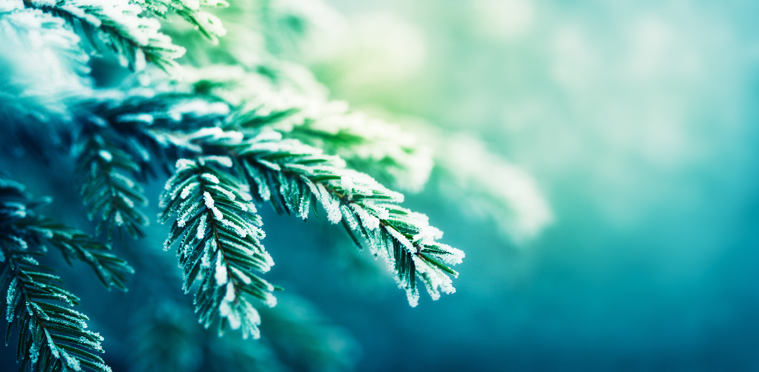
🌟 Bonus: Draw your roof designs on this page!

